**Summary of the power BI dashboard**

**Overview of the Paris 2024 Olympics Power BI Dashboard**

This Power BI Dashboard provides a comprehensive view of the Paris 2024 Olympic Games, focusing on athlete participation, medal distribution, coaching statistics, and discipline-wise analysis.

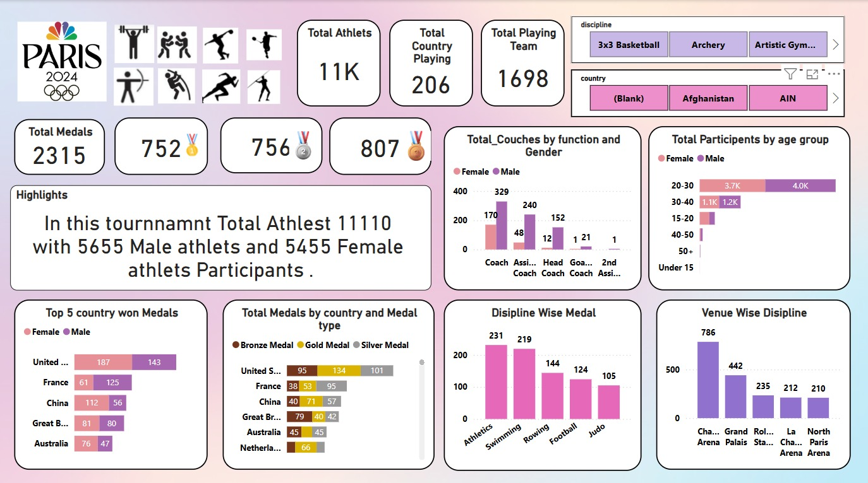

**1. Key Statistics**

* **Total Athletes: 11,110** 
  + Male Athletes: 5,655
  + Female Athletes: 5,455
* **Total Countries Participating: 206**
* **Total Playing Teams: 1,698**
* **Total Medals Awarded: 2,315** 
  + Gold Medals: 752 🥇
  + Silver Medals: 756 🥈
  + Bronze Medals: 807 🥉

**2. Medal Distribution**

* **Top 5 Countries with Most Medals:** 
  + United States – 187 Female | 143 Male
  + France – 61 Female | 125 Male
  + China – 112 Female | 56 Male
  + Great Britain – (Values Partially Hidden)
  + Australia – 76 Female | 47 Male
* **Medal Breakdown by Country & Type:** 
  + United States: 95 Bronze | 134 Gold | 101 Silver
  + France: 38 Bronze | 53 Gold | 95 Silver
  + China: 40 Bronze | 71 Gold | 57 Silver
  + Great Britain & Australia also feature prominently.

**3. Athlete & Coach Participation**

* **Total Coaches by Function & Gender:**
  + Male Coaches dominate Assistant Coach, Head Coach, and Goal Coach roles.
  + Female Coaches are significantly fewer in number.
* **Participants by Age Group (Male vs. Female):**
  + 20-30 Age Group – Highest participation (7.7K total)
  + 30-40 Age Group – Around 2.3K participants
  + Under 15, 40-50, 50+ Age Groups – Minimal participation

**4. Discipline & Venue Insights**

* Top Sports Based on Medal Wins:
  + Rowing – 231
  + Football – 144
  + Judo – 124
* Venue-Wise Discipline Distribution:
  + Champions Arena: 786
  + Grand Palais: 442
  + Roland Stadium: 235
  + Other Venues: 200+ participants each

**5. Key Insights**

**-Balanced Male-Female Participation** – Shows gender inclusivity in modern Olympics.  
- **US, France & China Dominate Medals** – These countries continue their sporting excellence.  
- **Athlete Age Group Trends** – Most participants fall within the **20-30 years** category, highlighting the prime years for Olympic-level performance.  
**-Coach Representation Disparity** – Male coaches outnumber female coaches significantly, indicating the need for **more diversity in coaching roles**.

**Conclusion**

This dashboard provides an analytical snapshot of the Paris 2024 Olympics, including medals, athlete demographics, country-wise rankings, and venue distributions. It helps in understanding sporting trends, participation levels, and key areas for improvement.

**Dashboard : 2**

This **Power BI Dashboard** provides insights into India's participation and performance in the **Paris Olympics 2024**. Below are the key takeaways:

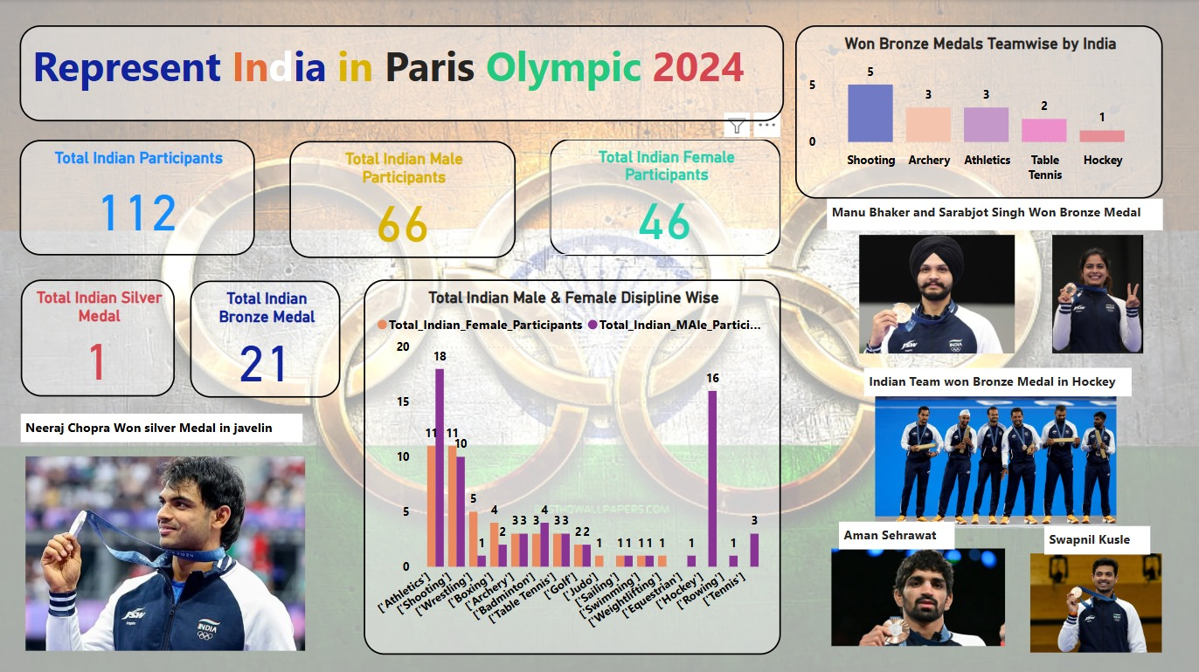

**1. Key Participation Metrics**

* **Total Indian Participants:** **112**
* **Total Male Participants:** **66**
* **Total Female Participants:** **46**

**2. Medal Tally**

* **Total Silver Medals:** **1**
  + *Won by Neeraj Chopra in Javelin Throw*
* **Total Bronze Medals:** **21**

**3. Bronze Medal Analysis (By Sport)**

* **Shooting** – 5 Medals 🏅
* **Archery** – 3 Medals 🏅
* **Athletics** – 3 Medals 🏅
* **Table Tennis** – 2 Medals 🏅
* **Hockey** – 1 Medal 🏅

**4. Athlete Highlights**

* **Neeraj Chopra** – Won **Silver Medal** in **Javelin Throw**
* **Manu Bhaker & Sarabjot Singh** – Won **Bronze Medals**
* **Indian Men's Hockey Team** – Won **Bronze Medal**
* **Aman Sehrawat & Swapnil Kusle** – Medal Winners

**5. Discipline-Wise Participation (Male vs. Female)**

* **Athletics**: 18 Male | 10 Female
* **Shooting**: 11 Male | 11 Female
* **Wrestling**: 11 Male | 5 Female
* **Boxing**: 4 Male | 3 Female
* **Archery**: 3 Male | 3 Female
* **Hockey**: 16 Male | 1 Female
* **Other Sports**: Badminton, Table Tennis, Golf, Swimming, Judo, Weightlifting, Rowing, and Tennis also have participants.

**6. Insights & Recommendations**

✅ **Strong Performance in Shooting & Athletics** – Continue investing in training & infrastructure.  
✅ **Hockey Team’s Success** – Boost grassroots development for future events.  
✅ **Gender Balance** – Need to encourage more female participation in high-impact sports.  
✅ **Focus on Silver & Gold Medals** – Identify training gaps to convert Bronze into higher medals.